Company Information

**Introduction:** Foodie is a dynamic and innovative startup food delivery company aiming to change the way people eat. We launched in 2023 and are eying to become a go-to site for foodies searching for various gastronomic treats delivered to their location of choice. Our objective is to create joy via food, to support local businesses, and to offer our delivery partners flexible income options.

Foodie is an online delivery food business that delivers food to consumers on demand from stores and restaurants. It is mainly a Platform Consumer Model. In the Platform To Consumers Model, restaurants will register themselves using applications and sell their foods to customers in their closeness, either through our website or mobile app. Customers can then order from these partner restaurants and have their food delivered by either the restaurant or a platform driver. Famous examples are DoorDash, Uber Eats, and Deliveroo.

Our initial idea is to provide services just in New South Wales, and we will likely take a 15-20% cut off the total cost of the order on top of any potential shipping costs. All payments will be made via credit/debit card.

Because we are a startup in this massive market, we will initially have roughly 8 members on board and 5-10 riders ready to deliver the food. Over the coming weeks, we are going to distribute our websites and aim to recruit top restaurants using our proposed approach. We will also seek to entice customers by offering various coupons and discounts. And as the week progresses, we will expand our riders and develop in all areas.

**Evidence of the competence of the people working in information security**

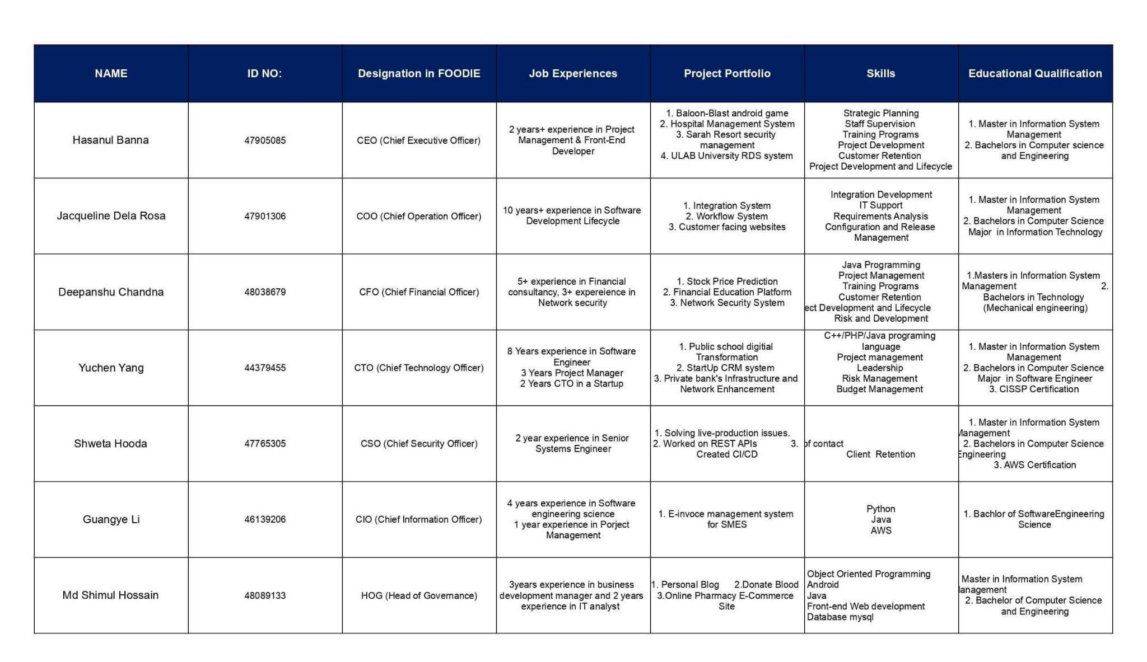

**Contact with authorities**

* Hasanul Banna: [hasanul.banna@students.mq.edu.au](mailto:hasanul.banna@students.mq.edu.au)
* Jacqueline Dela Rosa: [jcqlndelarosa@gmail.com](mailto:jcqlndelarosa@gmail.com)
* Deepanshu Chandna:[deepanshu.chandna13@gmail.com](mailto:deepanshu.chandna13@gmail.com)
* Yuchen Yang:[yuchen.yang2@students.mq.edu.au](mailto:yuchen.yang2@students.mq.edu.au)
* Shweta Hooda: [ms.shwetahooda@gmail.com](mailto:ms.shwetahooda@gmail.com)
* Guangye Li: [guangye.li@students.mq.edu.au](mailto:guangye.li@students.mq.edu.au)
* Md Shimul Hossain: shimul2019hossain@gmail.com

**Mission:**

To provide convenient and reliable food delivery services that connect customers with their favourite restaurants and food establishments, ensuring timely and delicious meals are delivered right to their doorstep. We aim to enhance the overall dining experience, saving customers time and effort while supporting local businesses in the process.

**Vision:**

Our vision is to become the leading and most trusted food delivery platform, revolutionizing the way people access and enjoy their favourite meals. We aspire to create seamless and enjoyable dining experiences for customers while empowering restaurants to expand their reach and grow their businesses. Through innovative technology and exceptional customer service, we aim to set new standards in the food delivery industry and be the go-to platform for food enthusiasts and businesses alike.

**Current demand for food delivery service**

If we look at the living conditions we have adapted to over the last two years, we can see that a phrase like in the year after the pandemic has emerged in our vocabulary. In short, while we suffered greatly throughout this period of transition, the world of technology presented us with new trends, thereby decreasing our deprivation to zero. From this vantage point, the pandemic can be viewed as the ideal set of conditions for many companies to get a foothold in the market.

From several surveys, the global market for online meal delivery was valued at $84.6 billion in 2018, but it rose 27% in a year to $107 billion in 2019. The $111 billion market value recorded last year demonstrates that people have grown accustomed to this way of living. The number of people using online meal delivery services is expected to reach 970 million by 2024. Companies such as Uber Eats, Delivery Hero, DoorDash, and Grubhub should continuously consider risk issues, particularly cyber threats.

**The business model we are using.**

There are several business models on the option, but we are going to implement The ***integrated food delivery model***, This model is flexible and Both admin and eateries can manage delivery in this manner. Many restaurants have their service pool and are looking for a venue to extend their products online. Online meal-ordering platforms that follow the integrated model may easily cater to such eateries.

Here, When a consumer puts an order from a restaurant, the admin decides if the restaurant permits self-delivery or uses the platform's delivery services, and then places the delivery accordingly.

**Advantages**: This concept would assist us in overcoming the risks of starting a new firm. The integrated concept enables restaurants to take part in the food delivery business whether they have a delivery fleet or not. Also, This business model allows for a broader selection of food outlets to be included on the platform, increasing the number of options for clients in terms of meals and restaurants.

**Challenges:** The major challenge we may face based on the integrated model is to streamline the delivery operations and assign delivery of every order as per the availability of the fleet with the restaurant. To overcome this challenge, we should look for a feature-packed online food delivery solution that enables the admin to easily assign delivery management to the restaurants.

**Why Do We Use Integrated Models?**

The integrated approach is the most preferred delivery food business model since it allows both the admin and the restaurants to control meal delivery.

Whether the restaurant has a delivery fleet or not, the integrated approach allows them to control meal delivery at their leisure. Several platforms are operating under the integrated meal delivery business model and providing the market's exponential growth. DoorDash is one such meal delivery platform that has established itself as the market leader in the country, capturing 45% of all food delivery orders in the country by 2020.

The following are some more facets that make the integrated food delivery business model the most ideal.

1. Admin exercises control over delivery service (Restaurant requires approval from admin to enable self-delivery option)

2, An additional Revenue Stream – Delivery Fee

3. Admin can ensure timely delivery and service quality

**How do we integrate the Foodie Model and how will it Work?**

**ADMIN**

1. Admin creates an account for delivery agents owned by himself.

2. Admin has the provision to enable/disable the delivery service provided by restaurants.

3. Admin sets up the delivery charges for the deliveries done by admin’s delivery agents.

4. The order is broadcast to all the delivery agents present in the delivery range of the restaurant.

5. If the order is not accepted by any delivery person, Admin can assign it to any delivery agent.

**Stores**

1. The store creates an account for the restaurant’s delivery agents (associated with a single restaurant or a restaurant chain)

2. The merchant enables the ‘self-delivery’ option to manage the order deliveries.

3. The delivery fee is set by the merchant for deliveries done by the restaurant’s delivery agents.

4. Every restaurant owner sets up a delivery range for their restaurants.

5. When the restaurant accepts an order, the order status tracked by the customer is changed to “Accepted”.

6. Then the restaurant prepares the order and updates the status to ‘Ready for pick-up’.

7. The restaurant owner is responsible for assigning the order to a particular delivery agent in case no delivery staff accepts the order on broadcasting. (When the delivery is managed by the restaurant)

**Delivery Staff**

1 . The delivery agents present in the delivery range of the restaurant get notifications about incoming orders.

2 . Once the order is accepted by a delivery person, the order status is automatically changed to ‘In-Preparation’.

3 . The assigned delivery staff picks up the order after receiving the notification that the order is ready for pick-up.

4 . The delivery agent can then update the status to ‘Order picked-up’.

5 . When the delivery person sets out to deliver the food to the customer, the portal tracks his/her route.

6 . When the delivery personnel covers half the distance, the system sends an in-app notification stating ‘your order is on the way’ to the customer.

7 . After delivering the order, the delivery person changes the order status to ‘Delivered’.

**Customers**

1. Customers can track their order status through regular updates.

2. Also, most of the online food delivery solutions enable Live Tracking for customers to track their orders in real-time.

**Potential Security Issues**

1. User data breaches
2. Payment system vulnerability
3. DDOS
4. Poor security training
5. Lack of Multi-factor Authentication
6. Cloud server security vulnerability

**Potential standards and frameworks**

1. ISO27001 - Mandatory. Internationally recognized standard. Implementing it can help manage and mitigate risks associated with information security. ISO27001 certification can also be a big competitive advantage in the Australian market.
2. ISO27002 - Optional. ISO27002 provides comprehensive security control guidance. It helps our company meet cybersecurity regulations. It can also help the company train the security awareness of the employees.
3. PCI DSS - Mandatory. As a food delivery company, we will handle a huge amount of card payments online through our app. This means compliance with PCI DSS is crucial. It will help us secure our customer’s credit card data and prevent payment fraud.
4. NIST Cybersecurity Framework - Optional. As a food delivery company, we keep a huge amount of customer personal information. Foodies can consider using this framework to mitigate cybersecurity issues and build a structured approach to protect customer data.
5. Cloud Security Alliance - Optional. If Foodie uses cloud service. CSA provides some of the best practices in this area.

**Potential IT Infrastructure**

Hybrid IT infrastructure or cloud-based infrastructure using AWS? =>better scalability and lower costs but more security concerns.

Software and Platform Selection:

* Foodie mobile app for customers
* Integration with the restaurant (order management system)
* CRM, financial software
* Data analytics and business intelligence tools (data-driven decision-making)

**Potential IT Strategy Development**

Need to align with Foodie’s business goals.

* Customer Experience and Engagement: a user-friendly mobile application with food recommendations, real-time order tracking, etc. Ensure a good ordering experience to retain and grow the customer base.
* Cost Efficiency: Utilize cloud services to avoid infrastructure costs. Cloud-based infrastructure can also expand as needed at cheap costs.
* Feedback system: Integrate feedback mechanisms within the app. Implement agile development methodologies to quickly iterate and introduce new features or improvements based on feedback.

**Technical Visions and Objectives**

**Customer Experience:** Develop an intuitive and user-friendly app interface that provides customers with a seamless and delightful experience when browsing menus, placing orders, and tracking deliveries.

**Restaurant Collaboration:** Foster strong partnerships with restaurants by providing tools and technologies that enhance their ability to manage orders, optimize menus, and offer personalized dining experiences.

**Data-Driven Insights:** Leverage data analytics and machine learning to gain insights into customer preferences, order trends, and restaurant performance, enabling data-driven decision-making.

**Enhanced Personalization:** Implement AI and machine learning to provide personalized recommendations for customers based on their previous orders, preferences, and location.

**Real-Time Order Updates:** Enable customers to receive real-time updates on the status of their orders, including estimated delivery times and live tracking of delivery partners.

**Optimized Delivery Routes:** Create an intelligent routing system that factors in variables like traffic, weather, and order volume to optimize delivery routes and reduce delivery times.

**Multi-Channel Access:** Build a consistent and responsive user experience across various platforms, including the web, mobile apps (iOS and Android), and potentially voice assistants and smart devices.

**Third-Party Integrations:** Integrate with third-party services, such as payment gateways, mapping services, and restaurant POS systems, to enhance the overall functionality of the platform.

**IT Infrastructure:**

**CRM System:** Customer relationship management (CRM) is a technology for managing all food company's relationships and interactions with customers and potential customers. The goal is simple: improve business relationships. A CRM system helps companies stay connected to customers, streamline processes, and improve profitability.

**Foodie APP**: The Foodie APP is a mobile application that facilitates the ordering, payment, and delivery of food from locals. APPs would both operate on the iOS and Android systems and provide the same user experience.

**Payment Gateway APIs** are a set of software interfaces and protocols that allow applications (such as websites, mobile apps, or point-of-sale systems) to process financial transactions securely and seamlessly, including payments made by customers. Potential choices: Visa, Mastercard, PayPal, Stripe, and Apple Pay

**Database:** The database for Foodie is mainly for storing and managing data like users, menus, orders, and delivery information. For foodies, it’s better to use a MySQL database with Redis (Remote Dictionary Server). Using MySQL with Redis can offer several advantages by leveraging the strengths of each database. Redis's speed, in-memory storage, and various data structures make it an excellent choice for caching and real-time analytics. By combining MySQL and Redis effectively, we can enhance application performance, scalability, and the overall user experience.

**Cloud Server:** AWS EC2 Server with CentOS 9 or RedHat Linux distros to deploy the application and web. The CentOS 9 or RedHat Linux distros provide a strong, stable Linux environment and professional enterprise support. Due to the huge user group and data flow, a stable operating system and a capable server matter.  
  
**GPS APIs**: Using them for delivery tracking and showing the route of local restaurant locations for pick-up service.

**Compliance requirements:** Compliance requirements for our company mainly depend on our nature and how we handle the process. As we are currently focusing on doing business only in NSW, it will be all based on this state. However, there are some common regulatory and legal obligations our business typically adhere to:

**Food Safety Regulations**:

We would Follow the HACCP (Hazard Analysis and Critical Control Points) system or other relevant food safety management systems to ensure the safe preparation and delivery of food. We would also Maintain proper temperature control for both hot and cold food items during storage and delivery to prevent bacterial growth and foodborne illnesses.

**Health and Safety Standards**:

We would Provide adequate training to your employees in areas such as food safety, sanitation, and workplace safety to ensure they are aware of best practices and will Maintain a safe working environment for your delivery drivers, including addressing safety concerns associated with driving, lifting, and handling food.

**Allergen Management:**

We also will ensure to make a clear list and label all allergens present in all items. This includes common allergens like peanuts, dairy, and gluten.

**Alcohol Delivery (if applicable):**

We may Obtain the necessary licenses and permits to sell and deliver alcohol, which can be subject to specific regulations and age restrictions. we also may ensure our delivery staff is trained to verify the age of customers when delivering alcoholic beverages.

**Vehicle Regulations:**

It’s a must that we ensure the delivery vehicles are regularly maintained and inspected to meet safety standards and emissions requirements, which may vary by location.

**Labor Laws:**

We will; try our best to adhere to to all labour laws, including minimum wage and overtime regulations. Ensure your employees are classified correctly as either employees or independent contractors based on local labour laws.

**Taxes:**

We will hire a team who will Collect and remit sales tax as required by your jurisdiction, and keep accurate records to facilitate tax reporting. And by complying with income tax regulations with the business profits and any employee withholding.

**Advertising and Marketing Regulations:**

We will strictly try to avoid false or misleading advertising claims and ensure that any endorsements or testimonials meet disclosure requirements.

**COVID-19 Regulations:**

By Complying with any specific pandemic-related regulations, such as mask mandates, social distancing, and contactless delivery requirements, depending on the public health situation in the delivery area.

**Applicable laws& regulations**

Certainly, there are business rules and regulations. To operate this business in New South Wales, Australia, these specific restrictions and regulations must be met. To maintain full compliance, we interact with regulatory authorities, obtain legal advice, and stay informed of any updates or changes to the rules and regulations that may affect our company.

**Food Safety and Hygiene:**

We need to inform all of our partners about maintaining proper food storage and handling practices to prevent contamination and ensure food safety. And we also need to employ a certified Food Safety Supervisor, who has completed the required training.

**Food Labelling:**

We need to ensure that all our delivered food items are accurately labelled with ingredients, allergen information, and nutritional content as per the Australian New Zealand Food Standards Code.

**Business Registration:**

We need to Register our food delivery business with the Australian Business Register (ABR) and follow local council requirements for business registration.

**Occupational Health and Safety:**

Develop and implement workplace safety policies and procedures to protect the health and safety of your employees and delivery drivers.

**Vehicle Regulations:**

We have to ensure that all delivery vehicles are registered, roadworthy, and meet emissions standards. And also need to Monitor vehicle maintenance and driver safety, including safe delivery practices.

**Employment Laws**:

Comply with employment laws, including minimum wage, working conditions, and employee rights as specified in the Fair Work Act 2009.

**Privacy Laws:**

Safeguard customer data and comply with the Privacy Act 1988 when collecting and using customer information.

**Public Health Regulations:**

Abide by public health regulations related to food handling, delivery, and storage, especially in the context of public health emergencies.

**Local Council Regulations:**

We need to Consult with our local council for specific regulations that may apply to our food delivery business, such as outdoor dining permits and waste disposal requirements.